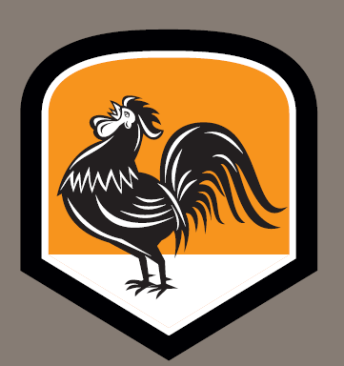
Hen & Chicken events
Kids party menus:
(min order 20)

Refreshments, served in 2.5pt jug
- Fruit juice £7.50
- Cordials £4.00
Sandwich menu: £2.50pp
½ round per child, served with potato crisps. Your choice of filings will be served in equal quantities. Please choose a maximum of 2 of the following, on either farmhouse white or malted granary. There is of course the option to change ingredients to suit – please just ask.
- Ham & tomato
- Tuna, mayonnaise & cucumber
- Prawns, mayonnaise & leaf
- Mature cheddar & hen pickle (v)
- Egg mayonnaise & watercress (v)
12 inch stone baked pizzas:
Please order any type and as many pizzas off our main menu.
These are charged at our normal menu price and will be pre sliced into 8 wedges

Finger food, served hot: £4.00pp
- Chicken goujons (crumbed or plain – you choose)
- Deep fried mac ‘n’ cheese balls (v)
- Honeyed cocktail sausages
- Traditional Hen mini hot dogs
- Halloumi fries, natural yogurt, molasses, pomegranate seeds (v)
Celebration cakes...
Families are of course welcome to bring their own birthday cakes to The Hen & Chicken

Extra items:
We are of course happy for you to order additional items off our main menu, please speak to one of our management team for advice on the practicalities of some items.

Please note:
Kids party menus must be pre-ordered with final numbers 7 days ahead of the event date. All events will be invoiced in advance and must be paid prior to the event.
Please also note that we do not permit self catered events.

