Sunday Roasts 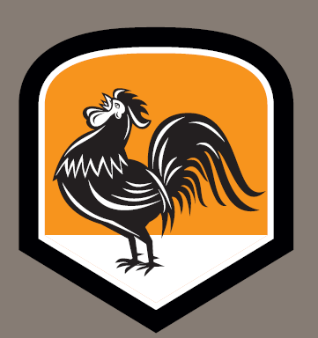
Sample menu

Small plates…
Grilled Halloumi (v), caper lime & coriander dressing £4.00

Caesar salad £4.50

Baked mushroom (v), garlic, parsley & gorgonzola £4.50

Salt’n’pepper squid, sweet chilli sauce £5.50

Roasts…

Rare roast rolled sirloin of beef £12.50
Yorkshire pudding

Free range roast chicken breast £11.50
Sage & sausage stuffing

Slow roast belly of pork £11.00
Sage &sausage stuffing

Sweet potato and lentils nut roast (V/GF) £10.00
Red onion gravy,

Children’s roasts £6.50

All roasts served with roast potatoes, honey & thyme roasted parsnips,
carrots, winter greens & gravy

Cauliflower cheese (for 2 to share) £3.50

Specials

Quinoa & date roasted roots salad (VG/GF) £10.00
Edamame beans, grated carrot, tender stem broccoli, spinach, toasted pumpkin seeds

Pan fried filet of Salmon £11.00
New potato, Sauté broccoli and kale , tomato capers sauce

Our full pizza menu is also available

Pizzas (served from 12 noon)

Pizza breads (v) garlic & rosemary or tomato & pesto £4.50
Dough balls (v) sweet chilli or garlic butter £3.00

Margherita (v) £8.00
with buffalo bocconcini £9.00

Scotch Bonnet Chilli........ £11.00
spicy pepperoni, chilli pork, peppers, jalapenos

Smoked Sausage £10.00
broccoli, Taleggio, red onion, mushrooms

Cumin Spiced Cauliflower (v) £9.00
roast peppers, sweet potato, goats cheese

Butternut Squash (v) £11.00
Gorgonzola, red onion, pesto, spinach

Chorizo & Egg £11.50
cherry tomatoes, mushrooms, black pudding

Tuna Melt £9.50
green peppers, sweet corn, red onion, capers

Spicy Chicken £10.00
cajun chicken, jalapenos, guacamole, red onion

Duck & Hoisin £10.50
cucumber, spring onions

extra pizza toppings £1.25

Puddings, Sundaes & Waffles

Sticky toffee pudding, toffee sauce £5.00

Deep filled American apple pie, double cream £5.00

Marshfield Farm ice-creams £1.30 per scoop

Big American waffles made freshly to order: All at £5.00

Apple Crumbled: crumbled apple pie, custard & Clotted Cream ice cream

Banoffee: banana, toffee sauce, salted caramel ice cream, toffee popcorn

Mighty Maple: maple syrup, cinnamon, icing sugar & clotted cream ice-cream

Oreo: crushed oreos, fudge sauce, cookies & cream ice cream

Ice cream Sundaes: All at £5.00

Eton Mess:
strawberries in clotted cream & clotted cream ice creams, fresh strawberries,
crushed meringues, whipped cream & strawberry sauce

Oreo Heaven:
chocoholic heaven & clotted cream ice creams, crushed oreos, whipped cream & chocolate sauce

Rocky Road:
cookies ‘n’ cream & chocoholic heaven ice creams, rocky road chunks, mini marshmallows,
whipped cream & chocolate sauce

